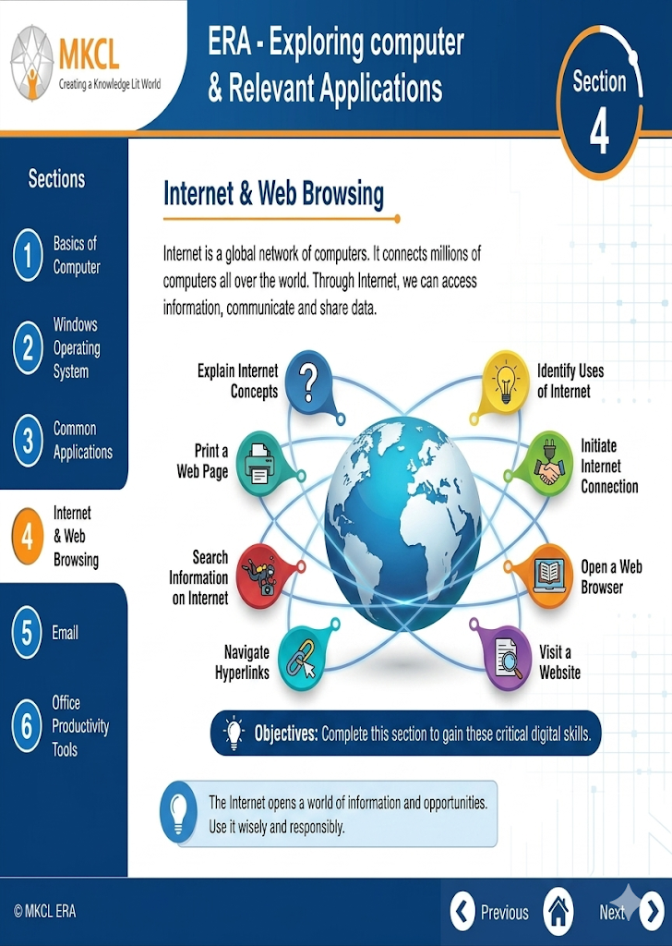

🌐 1. Internet Basics
- The Internet is a global network connecting millions of computers.
- It allows sharing of information through websites, emails, apps, etc.
- Key terms:
  - ISP (Internet Service Provider) – company that gives internet access (e.g., Jio, Airtel)
  - IP Address – unique number identifying a device
  - Domain Name – human-readable website name (e.g., google.com)

🌍 2. Web & Browsers
- World Wide Web (WWW) – collection of web pages on the internet
- Web Browser – software to access websites
Examples:
  - Google Chrome
  - Mozilla Firefox
- URL (Uniform Resource Locator) – address of a webpage

🔎 3. Search Engines
- Tools used to find information online
- Examples:
  - Google
  - Bing
- Tips:
  - Use keywords
  - Use quotes for exact search
  - Check reliable sources

📧 4. Email Communication
- Email = Electronic mail used for sending messages
- Parts:
  - To
  - Subject
  - Body
  - Attachment
- Email services:
  - Gmail
  - Outlook

💬 5. Online Communication Tools
- Chat, video calls, messaging apps
- Examples:
  - WhatsApp
  - Zoom
- Used for education, business, and personal communication

⚠️ 6. Internet Safety & Security
- Common threats:
  - Viruses & Malware
  - Phishing (fake emails/websites)
  - Hacking
- Safety tips:
  - Use strong passwords
  - Don’t share OTP/password
  - Install antivirus
  - Avoid unknown links

🔐 7. Digital Etiquette (Netiquette)
- Be polite online
- Avoid spam and abusive language
- Respect privacy
- Don’t spread fake news

📂 8. Downloads & Uploads
- Download – receiving files from internet
- Upload – sending files to internet
- Be careful while downloading unknown files

📌 Quick Revision Points
- Internet = network of networks
- Browser = tool to access websites
- Email = digital communication
- Search engine = helps find information
- Stay safe: passwords, antivirus, awareness

